How to Use BeAM Certified Cura Profiles
  - For 3D printing on the Ultimaker³ with Colorfabb XT

Table of Contents
Getting the BeAM Certified Cura Profiles 2
Where Can I Find Them? 2
How Do I Import Them? 3
Choosing Which BeAM Certified Cura Profile is Right for You 8
Choosing the Fast Profile 8
Choosing the Normal Profile 8
Choosing the Fine Profile 8
Where to Find Additional Help? 9

Getting the BeAM Certified Cura Profiles
In this section we will discuss how to acquire the BeAM certified Cura profiles and import them into Cura.

Where Can I Find Them?
You can find the BeAM certified Cura profiles on any of the BeAM supplied USB drives that are used for transporting your 3D files from your computer to the 3D printers and under Resources at beam.unc.edu. By searching for “BeAM Colorfabb XT” or “.curaprofile” in your computer’s file explorer, you should be able to easily find the “Fast”, “Normal”, and “Fine” profiles.

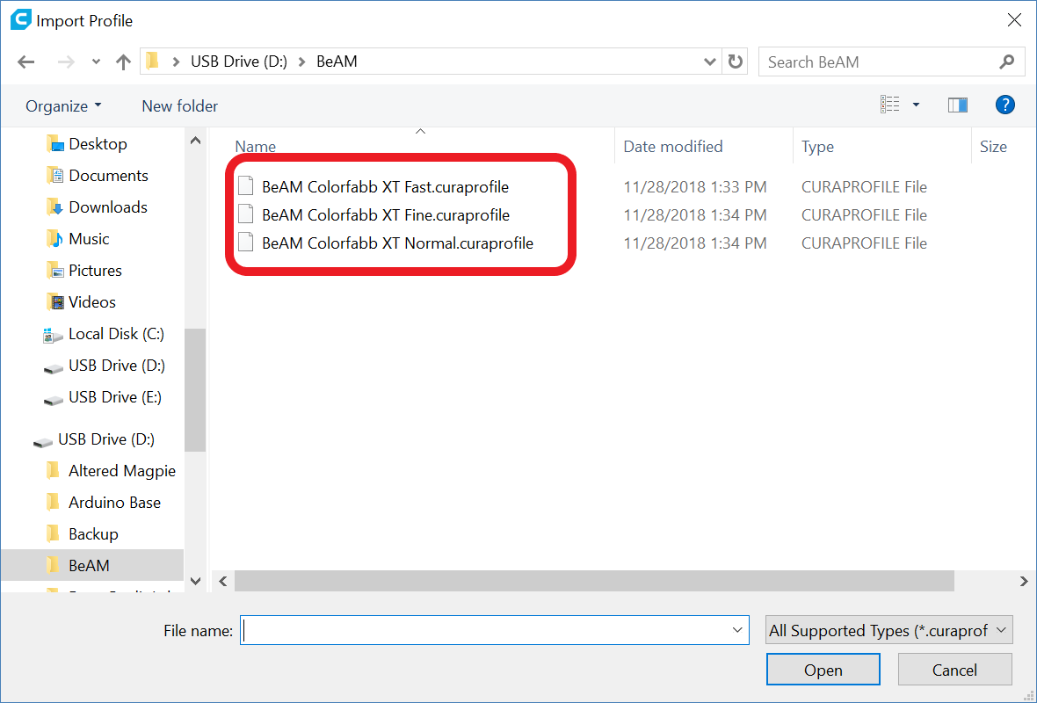
  - The BeAM Certified Cura Profiles in a Windows 10 File Explorer

How Do I Import Them?
Once you have located the three BeAM certified Cura profiles, you will need to open the Cura application installed on your laptop. Once the application has opened you should find yourself on the “Prepare” page. If it does not open to the “Prepare” page you can navigate to it by selecting the “Prepare” tab from the top navigation bar (next to the “Monitor” tab).

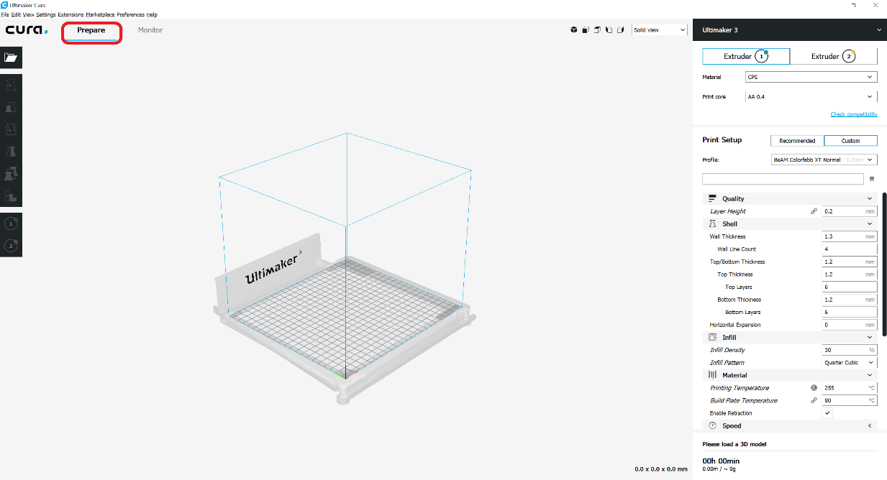
The Cura Application Prepare Page

On the prepare page, you want to locate the “Print Setup” menu, found on the right-hand navigation panel. You then want to ensure that the “Custom” button is selected (indicated by a blue glow around the button border) instead of the “Recommended” button.

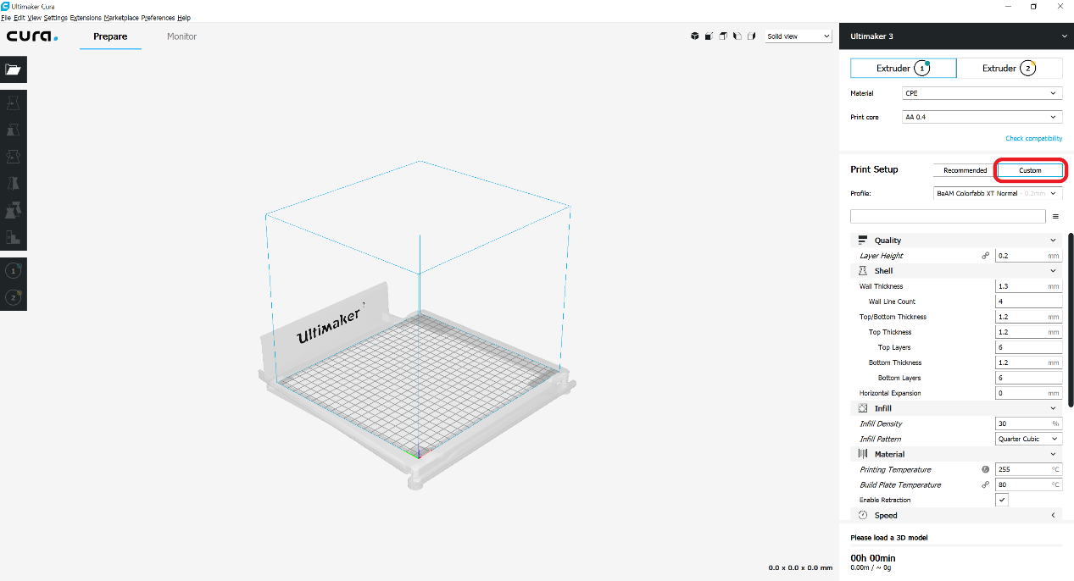
The “Custom” Button to Select from the Right-Hand Navigation Panel

Having selected the “Custom” button, you then need to select the “Profile” dropdown menu. Once imported, this dropdown menu will allow you to select which BeAM certified Cura profile you’d like to print with. From the bottom of the dropdown menu, you want to select the “Manage Profiles…” option. Selecting this option should open a “Preferences” window for managing your “Profiles”.

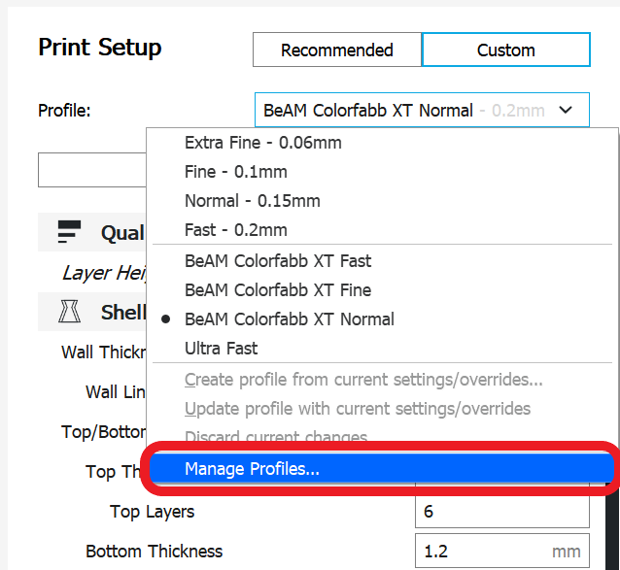
The “Profile” Selection Dropdown Menu & “Manage Profiles…” Option

To import the BeAM certified Cura profiles you need to click the “Import” button on the top navigation bar. Clicking this button should open your computers file explorer. Once open, you want to navigate to the BeAM USB drive and locate the three BeAM certified Cura profiles. You will need to select each profile one at a time, as you can not import multiple profiles at once.

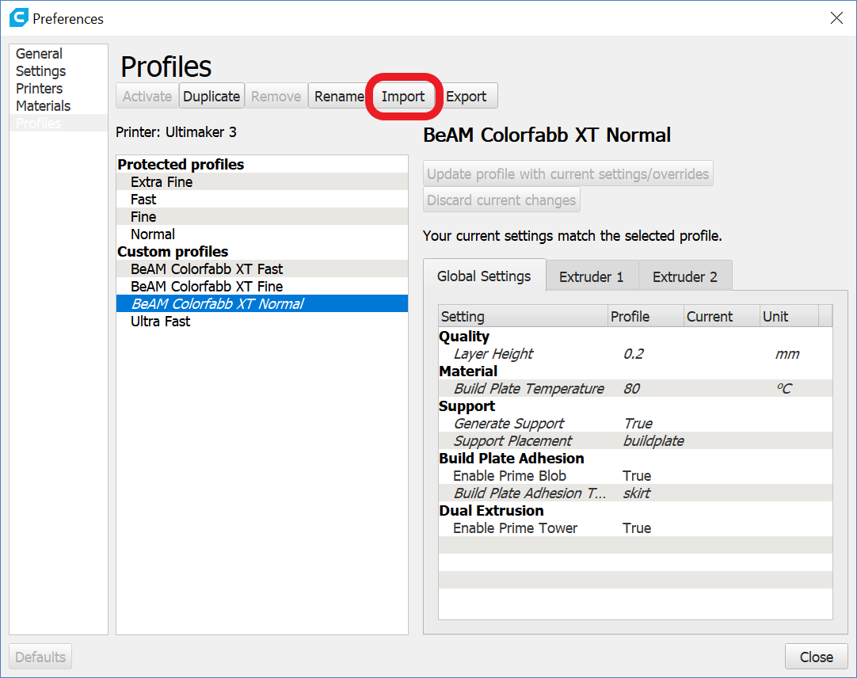
The “Preferences” Window & the Import Button to Click

Once you have imported all three BeAM certified Cura profiles (“BeAM Colorfabb XT Fast”, “BeAM Colorfabb XT Normal”, and “BeAM Colorfabb XT Fine”) you should see them listed under the “Custom Profiles” menu in the “Preferences” windows as well as the “Profile” dropdown menu.

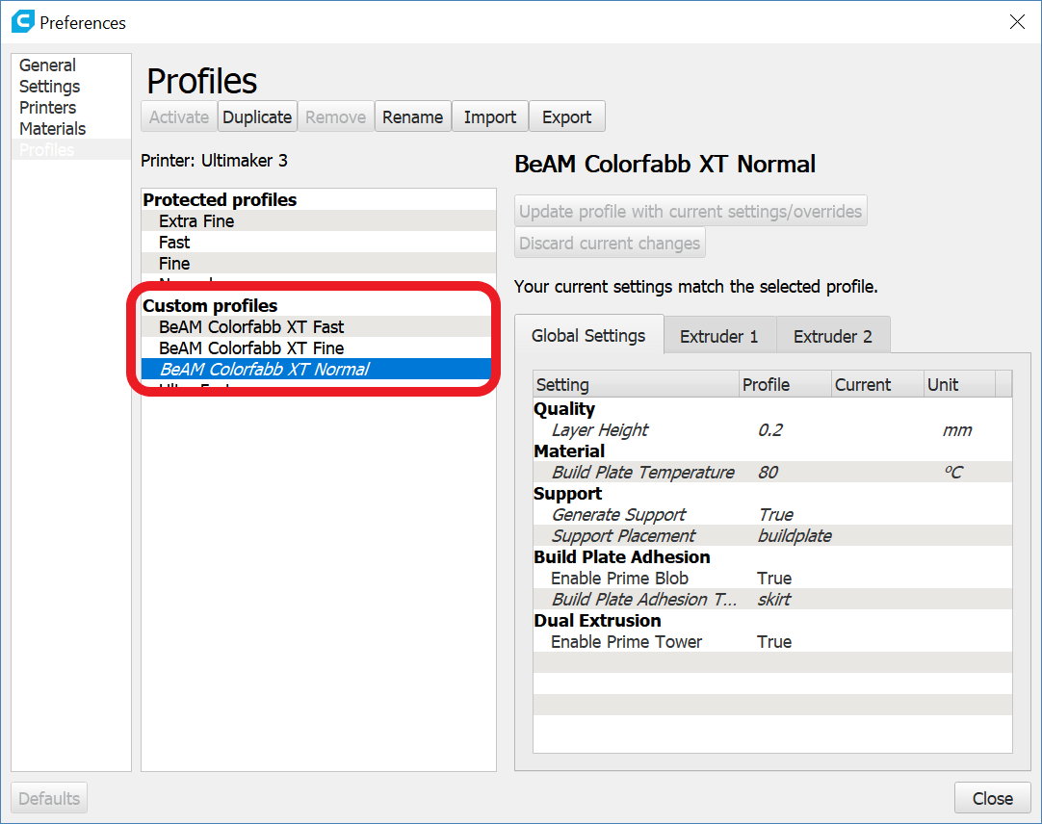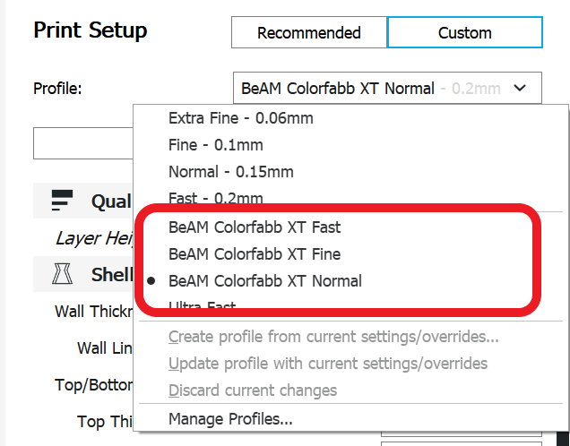
The BeAM Certified Cura Profiles Listed in the “Preferences” Window & the “Profile” Dropdown

Choosing Which BeAM Certified Cura Profile is Right for You
In this section we will discuss how you can determine which BeAM certified Cura profile to choose for your 3D print to optimize both time and material use.

Choosing the Fast Profile
  - BeAM Colorfabb XT Fast
There are two benefits to choosing the “BeAM Colorfabb XT Fast” Cura profile for your 3D print. The first benefit is right in the name. Printing with the fast profile can cut a considerable amount of time off your 3D print allowing you to assess any potential flaws in your design and make changes quickly. The second benefit is that your print will require less filament, helping conserve the resources we provide for free at BeAM. This is perfect for prototyping an idea or printing something for fun. And in case you’re wondering, there is little to no discernable difference between an object printed with the fast profile versus the normal profile.

Choosing the Normal Profile
  - BeAM Colorfabb XT Normal
When compared to the fast profile, choosing the “BeAM Colorfabb XT Normal” Cura profile has few perks. Not only will it add a considerable amount of time to your 3D print, but it will also require more filament than the fast profile. The only benefit of choosing the normal profile over the fast profile is a small gain in print quality (decreased layer height), which can be hard to notice without making a detailed side-by-side comparison. For the most part, you should only use the normal profile when printing your finalized design.

Choosing the Fine Profile
  - BeAM Colorfabb XT Fine
Although rare, there are circumstances where your 3D print may require you to choose the “BeAM Colorfabb XT Fine” Cura profile. However, unless you have a definitive, well-thought out, and preferably tested reason for requiring the fine profile, odds are you really don’t need it. But, if you determine that your 3D print does require the fine profile, be sure to contact a professional staff member for approval before continuing with your print. Due to the considerable amount of additional time and filament that 3D prints using the fine profile require, you are not permitted to print using the fine profile without professional staff approval. If you are caught printing with the fine profile without prior permission from a professional staff member, your print will be cancelled without notice. If you have any questions regarding contacting a professional staff member, feel free to ask student staff for assistance.

Where to Find Additional Help?
If you require additional assistance with any of the content covered in this manual, please do not hesitate to reach out to a student staff member working in the makerspace. We are all happy to help in any way we can, and if we do not personally know the answer to your question, we can help to get you in contact with someone that does.

